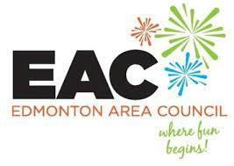
Meeting Agenda

Date and Time: April 14, 2026 @ 5:30 pm

Venue: AUPE HQ, 10025 182 Street NW, Edmonton

- Call to Order

- Quorum

- Treaty Acknowledgement / Statement of Equality

- Introduction: Executives and Members

- Approval of the following:
a) Meeting Agenda
b) Meeting Minutes of March 17, 2026

- Treasurer’s Report

- Old Business
- Movie Morning – May 30th
- Group Camping – July 31st to August 3rd
- Summer BBQ Picnic – August 29th

- New Business
  - Annual General Meeting May 26th (in-person/virtual)
  - Edmonton Riverboat event (July/Aug)
  - BINGO
  - EAC event ideas

- Next meeting date: May 26, 2026 (AGM)
June 2, 2026

10. Adjournment

https://edmontonareacouncil.aupe.ca

Bring your own water bottle

“Moderation when wearing scented products should be exercised by all members attending”

